Week 8 workshop
- Create a CUDA program to find the first 1 million prime numbers that uses 10 blocks and 100 threads. For this question, you will need to use the formula found in the larger squaring program on Canvas to get the unique id of the thread. This is because you are using more than 1 block. Each thread should find the same amount of prime numbers and store them into an array on the GPU. Once all threads have been completed, the GPU array memory is copied back into the CPU memory, then print them out onto the terminal.
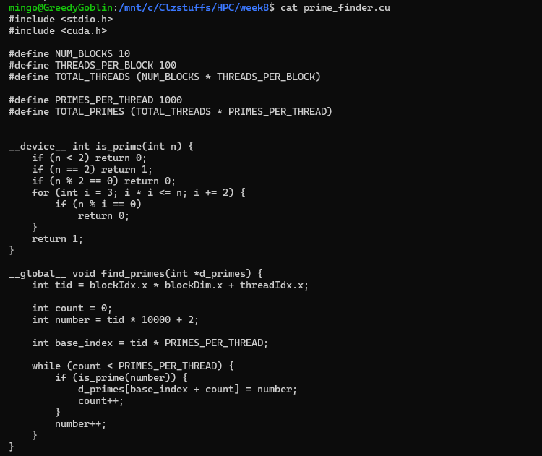
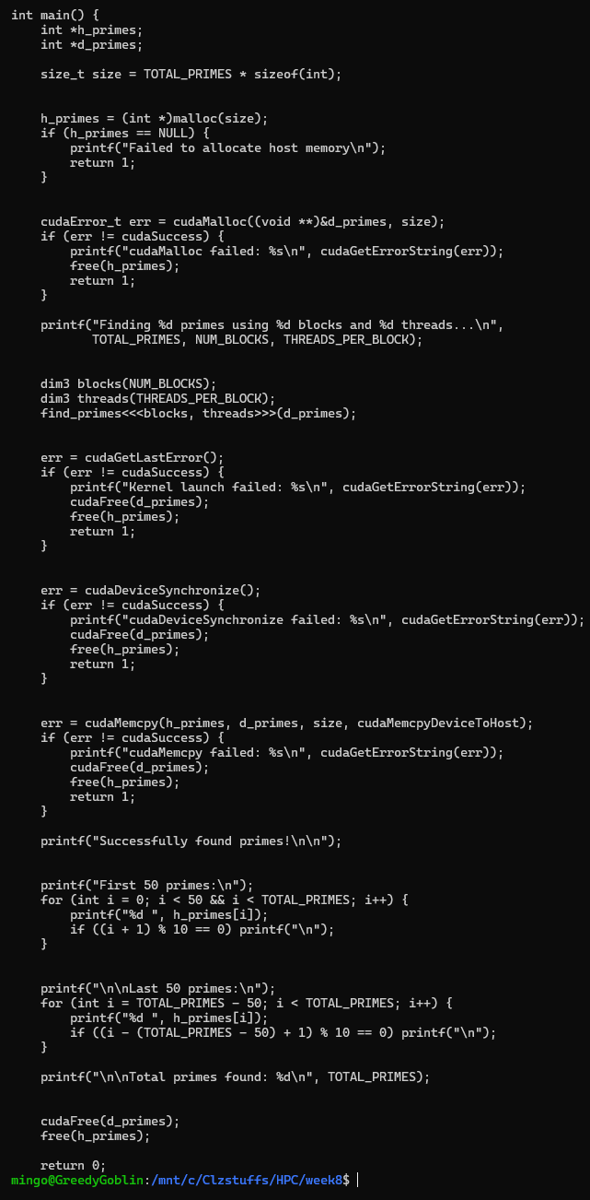
output
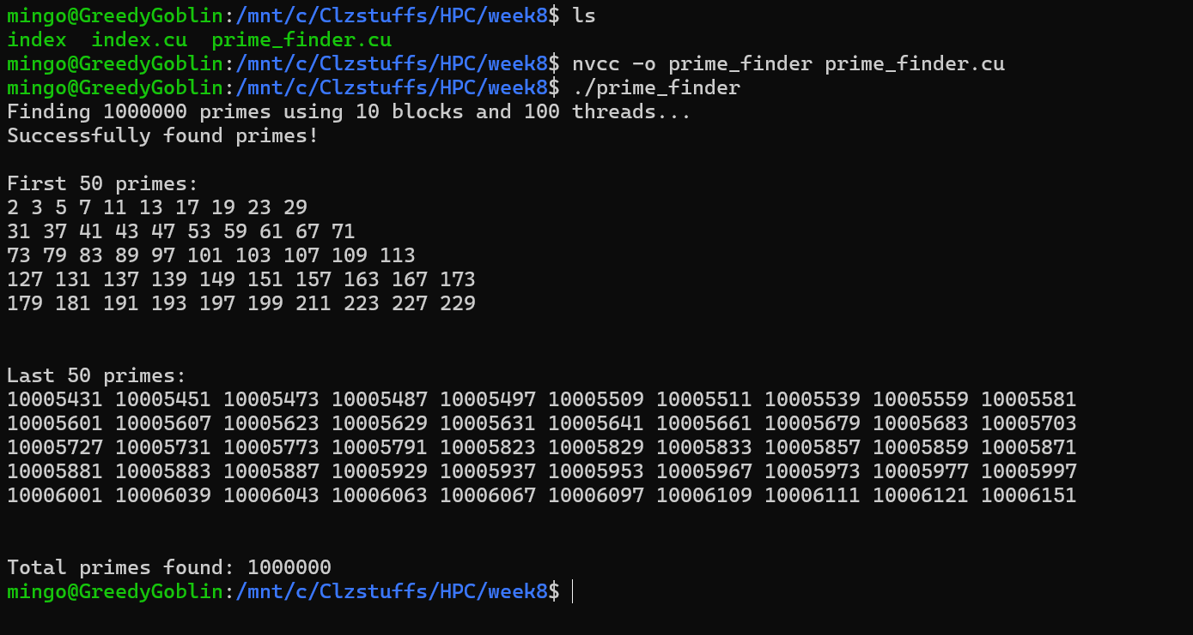
2. Create a program that calculates an estimate of Pi using the Leibniz algorithm in CUDA. You should first create a standard CPU program (preferably multithreaded) and then convert this into CUDA. Do a comparison of your CPU program to your CUDA version and analyse the time difference. Change the number of blocks and threads and see whether this has any effect on the time. We will discuss this at the next Lecture. Below is the formula:
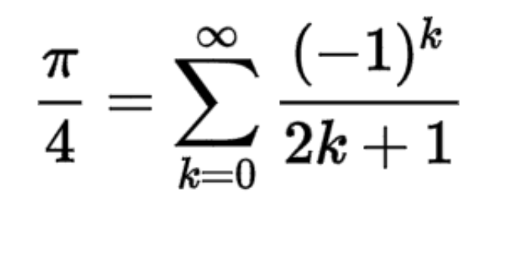
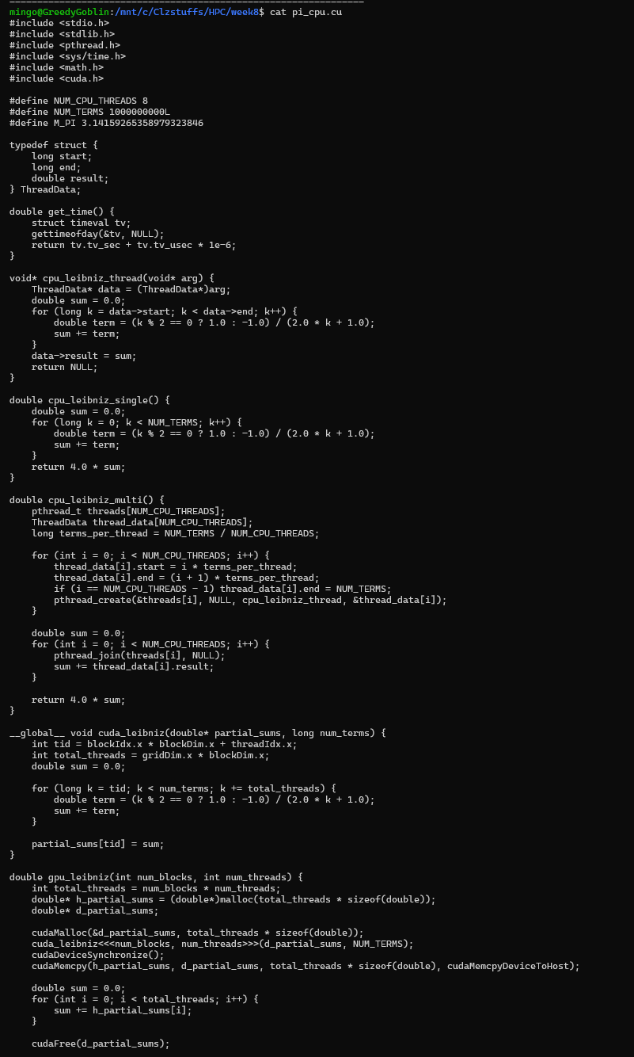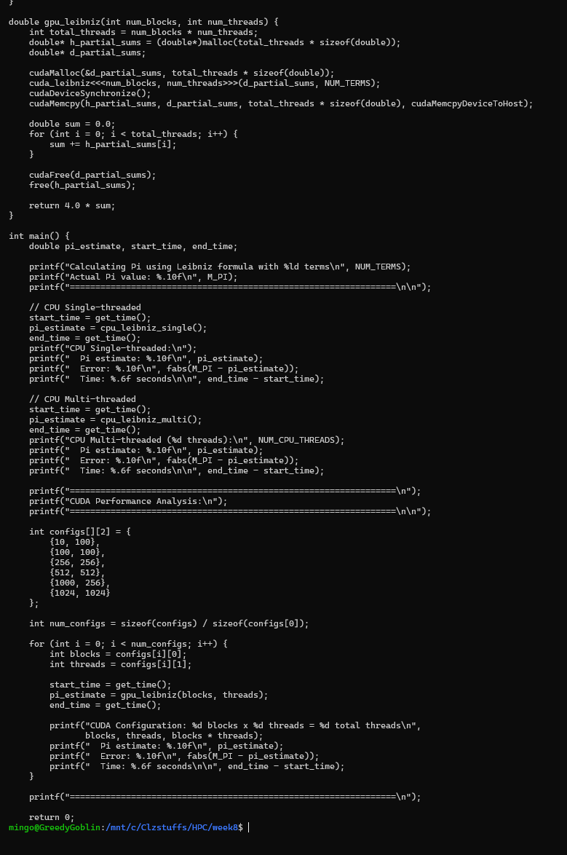
Output
